Chapter 16, Problem 77.

Obtain the transfer function H(s) = V_{o}/V_{s} for the circuit of Fig. 16.96.

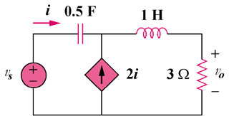

Figure 16.96
For Prob. 16.77.

